Project 1

1. Create a Login Screen on an Activity

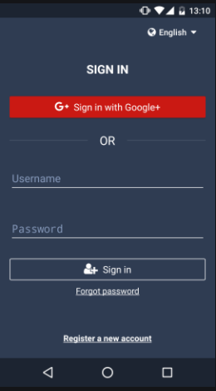

1. On Click of Forgot password, create a new fragment and give him option of edit text box to enter the old password and new password and have a submit button
2. On Click of the **Register new Account**, take him to the registration page

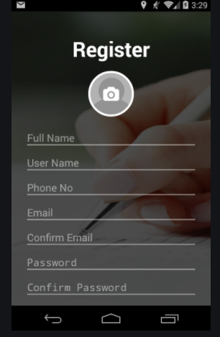

1. Store the registration data in the Shared Preferences
2. Based on the data stored in the shared preference (username and password), make the user login
3. Once user login … taking him to the landing page where the RecyclerView is shown (add images and text in the staggered format)

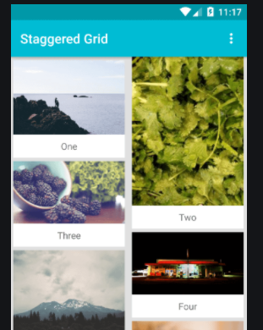

1. Once the User Clicks on the any of the image, open that image in a full size on a fragment.
2. Implement the Logout functionality.